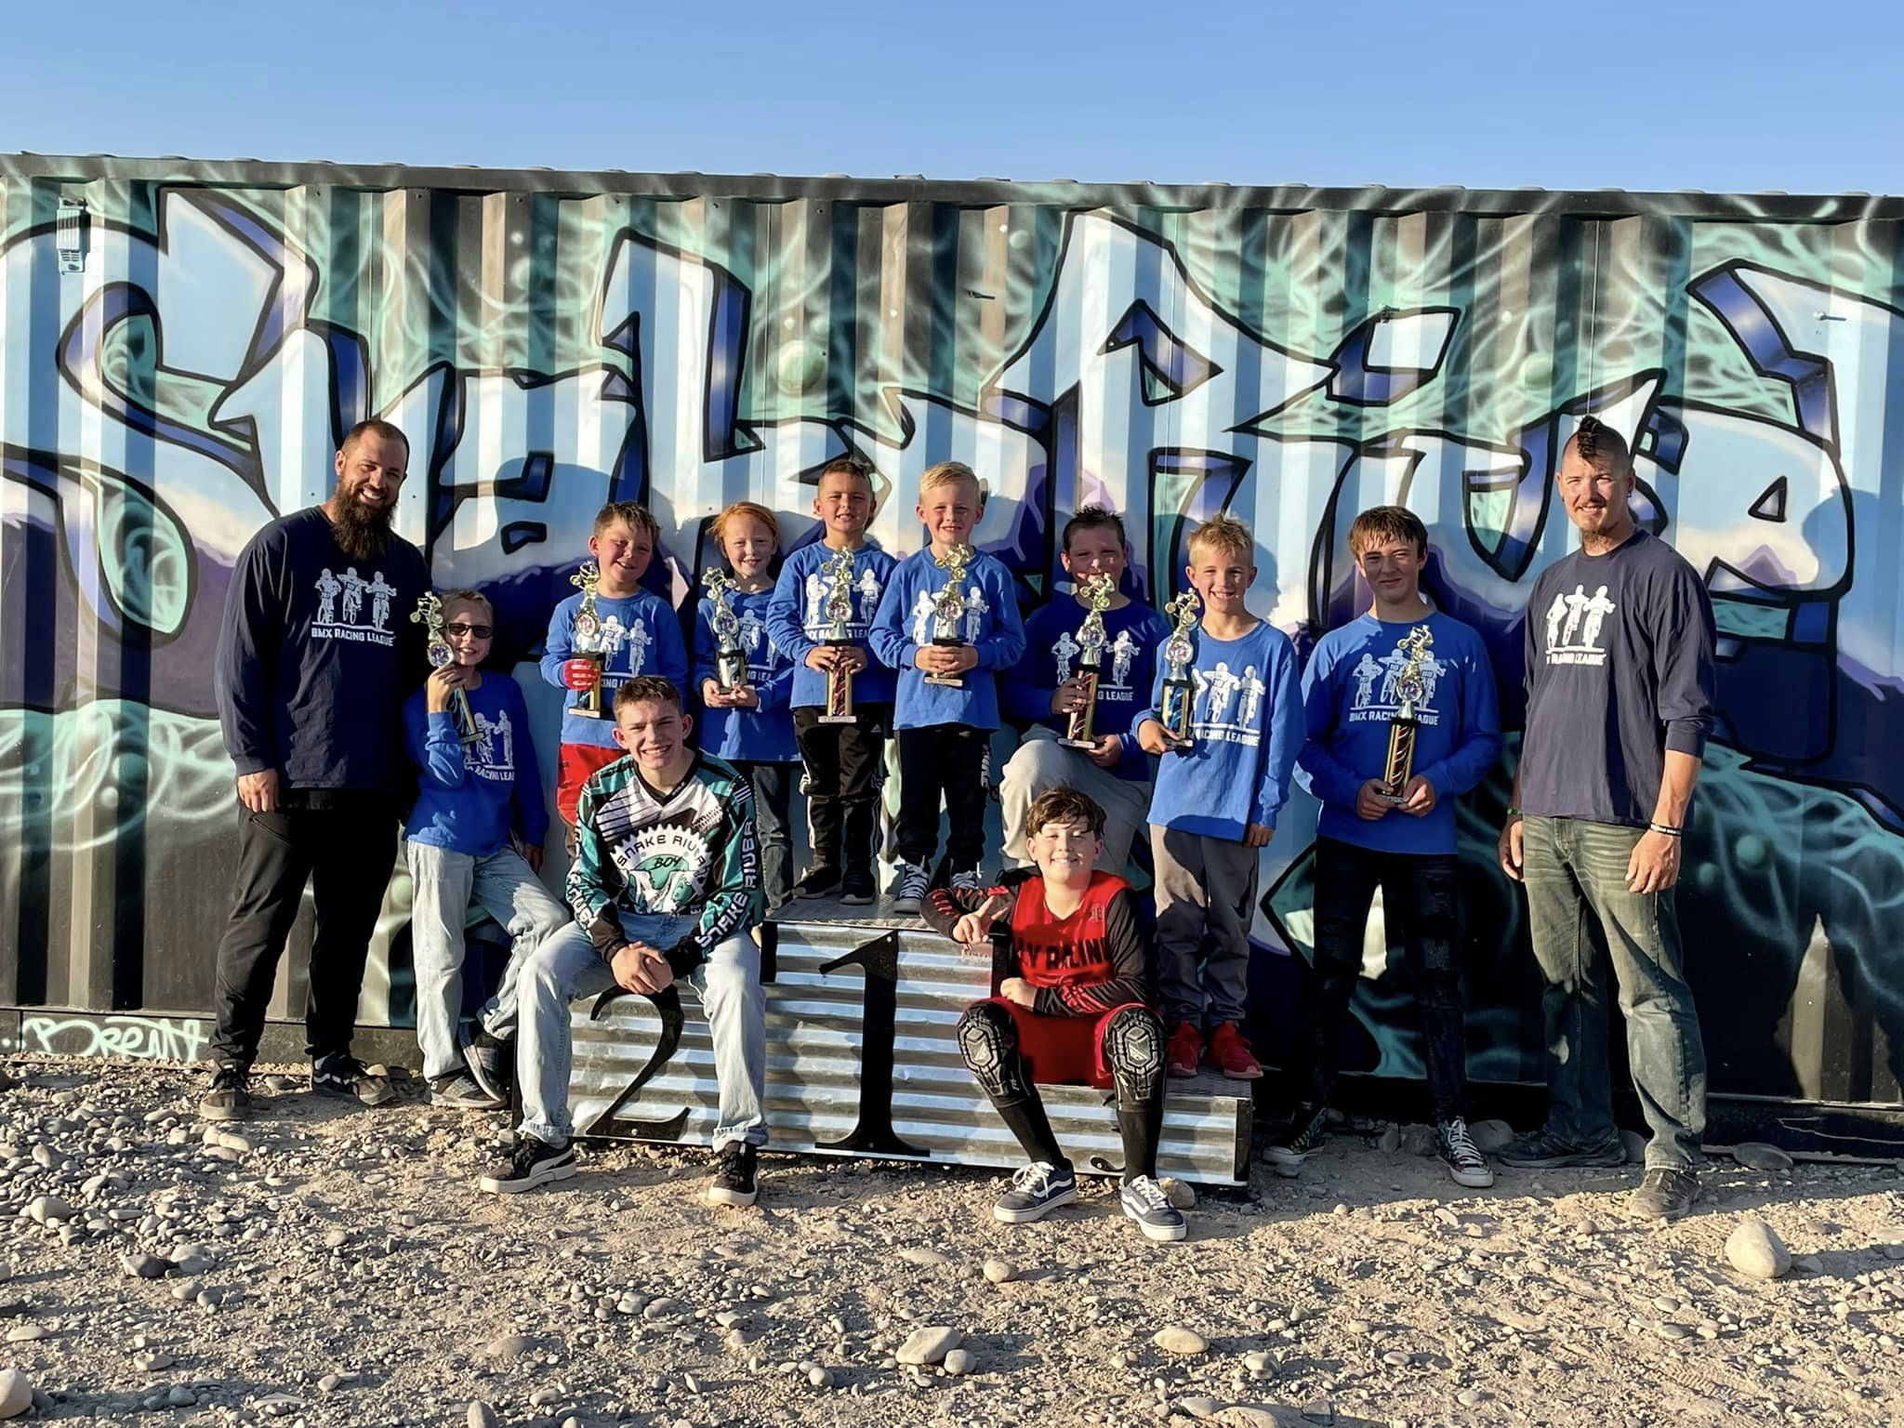

PARTNERSHIP PROGRAM

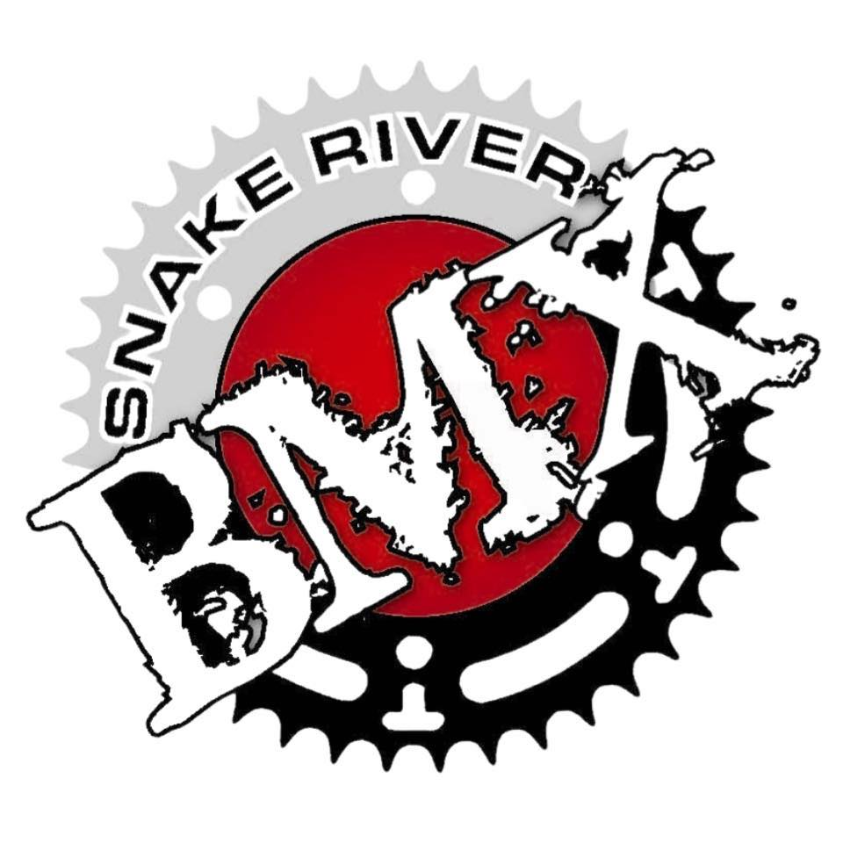

WWW.SNAKERIVERBMX.COM
Track Operator: Casey Christensen (435-764-7086)
1860 E 65th South, Idaho Falls, ID

SNAKE RIVER BMX
Our History

Snake River BMX has been in East Idaho for over 40 Years.
Stan Murdock helped create Snake River BMX in the late ’70s.
We have been located at three different locations in Idaho Falls.
In 2022 we moved from Beaches Corner to Sandy Downs.
2022 we leased property from The City of Idaho Falls.
We are a 501c3 Non-Profit fully run off volunteers and donations.
We earned the Idaho State Final Championship Race in 2022 & 2023.

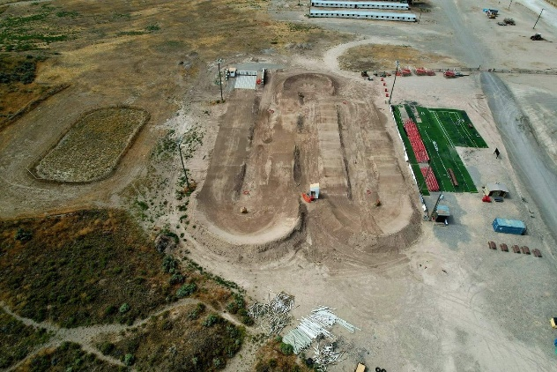
Facility

Our facility is located at Sandy Downs.
We have a huge facility with over 500 parking spots.
We have an area set for a Strider/Pump Track.
We are big enough for a National and Gold Cup Final.
We offer dry overnight camping.
Our track is 1200 Feet Long.
Our location is on the outskirts of Idaho Falls

What We Do
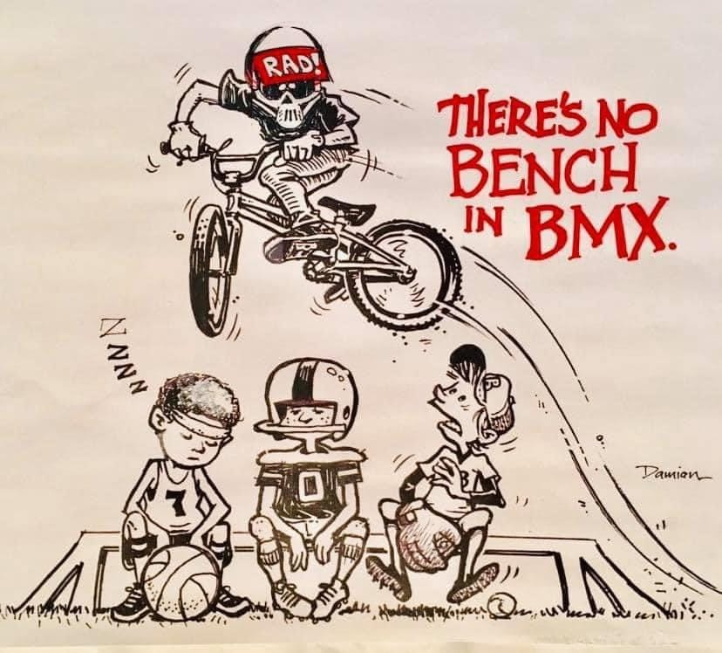
We race Bicycle Motocross known as BMX.
Our ages range from 1 to over 65 years of age.
Race from April until the end of October.
Offer a family environment of fun and racing.
Rent the track out for parties.
Reach kids who do not fit in in other sports.
Race every Tuesday and Thursday.
We support local bike shops and businesses.
Rider’s league is for kids who want to learn the sport.
Offer clinics for beginners and advanced riders.
Donations to Ronald McDonald House.
Every kid gets to race, no one is turned away.
Offer rental bikes and helmets for those in need.

THE SPORT OF BMX & SNAKE RIVER BMX

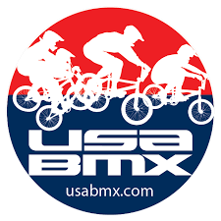
- BMX is one of the fastest growing sports in the Nation.
- SNAKE RIVER BMX is fully run by VOLUNTEERS.
- SNAKE RIVER BMX is a 501c3 Non-Profit.
- There’s NO BENCH IN BMX, everyone races.
- Fathers, Mothers, Children, and Grandparents can all race together.
- BMX has different Classifications:
Strider, Novice, Intermediate, Expert, Girl, Pro, Class, and Cruiser.
- USA BMX has over 300 sanctioned tracks across the nation,
Snake River BMX is one of them.
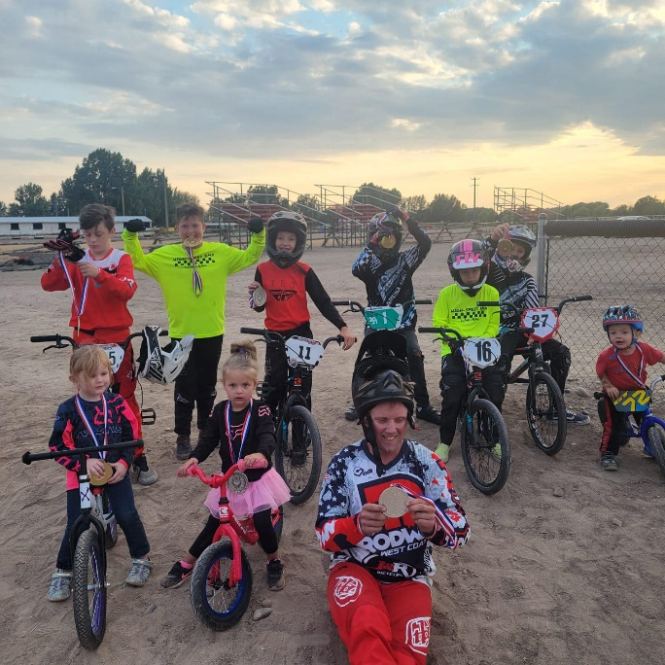

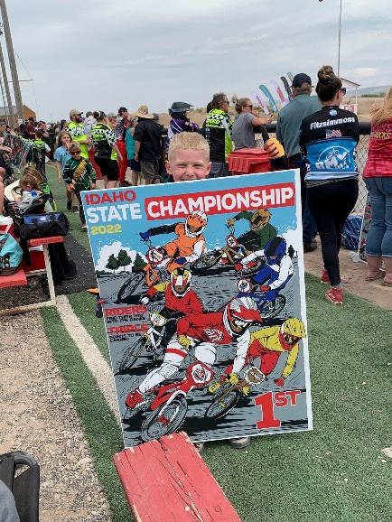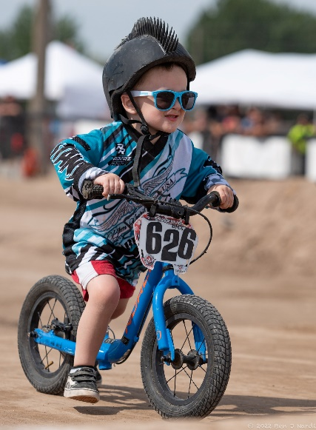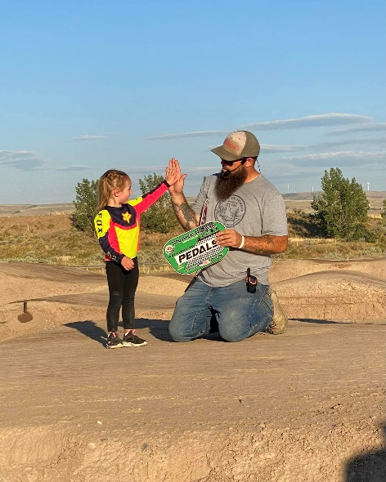
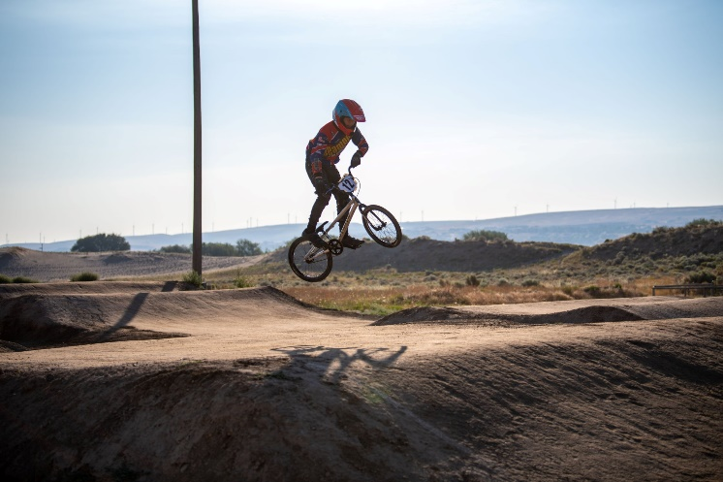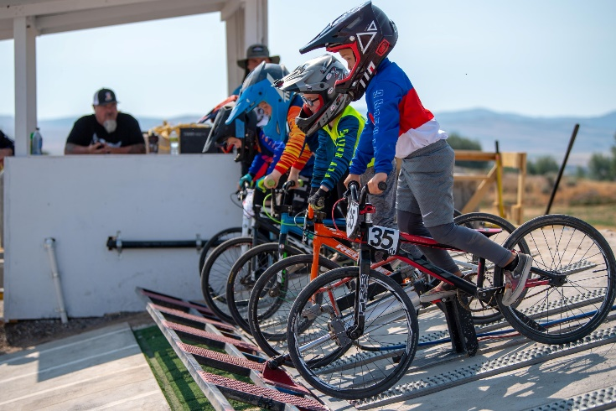
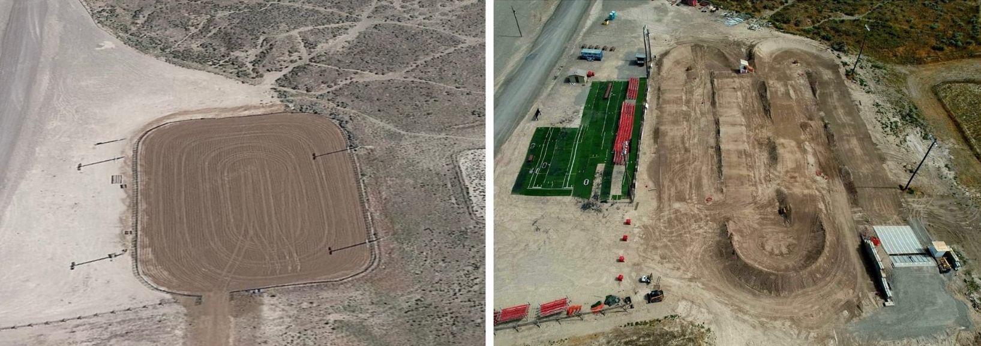
PARTNERSHIP LEVELS

- GOLD CUP PACKAGE | $1000
  - 36x84 Jumbo Sign with Company Logo
  - Your Company Announced at Every 2023 Snake River BMX Race
  - Logo and link on Facebook and www.snakeriverbmx.com
  - Snake River BMX Hoodie(1) or Shirt(2)
- STATE FINAL PACKAGE| $700
  - 36x84 Jumbo Sign with Company Logo
  - Your Company Announced at Every 2023 Snake River BMX Race
  - Logo and link on Facebook and www.snakeriverbmx.com
- DISTRICT PACKAGE | $500
  - 24x72 Sign with Company Logo
  - Your Company Announced at Every 2023 Snake River BMX Race
  - Logo and link on Facebook and www.snakeriverbmx.com
- STRIDER PACKAGE | $300
  - Logo and link on Facebook and www.snakeriverbmx.com
- START HILL PACKAGE | Other
(Cash Donation, Gift In-Kind, Labor, Materials, Services)
  - Company (or Person) Listed on Partnership Banner for Snake River BMX Big Weekend

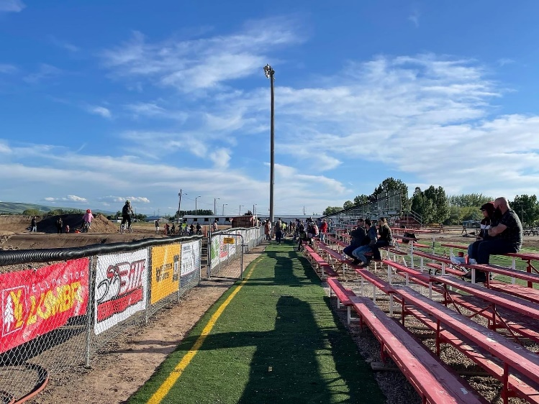
RACE SCHEDULE

Race Projections and Partnership Program Exposure
RACE SEASON IS FROM APRIL/MAY THROUGH THE END OF OCTOBER.
RACE/EVENT FREQUENCY RIDERS GUESTS TOTAL

TUESDAY RACING WEEKLY 95 205 300+

WED PRACTICE WEEKLY 50 100 150+

THURSDAY WEEKLY 95 205 300+

BOB WARNICKE ANNUAL 95 205 300+
SCHOLARSHIP RACE

RACE FOR LIFE ANNUAL 95 205 300+

EARNED DOUBLE ANNUAL 125 375 500+

STATE QUALIFIER ANNUAL 225 700 925+
DOUBLE POINT RACE

STATE FINAL
CHAMPIONSHIP RACE ANNUAL 350 850 1200+

BREAST CANCER ANNUAL 95 205 300+
AWARENESS RACE

BOB WARNICKE SCHOLARSHIP RACE- The Warnicke Scholarship Race was created to help fund The Bob Warnicke Memorial Scholarship Fund which assists students and their families in meeting the costs of undergraduate college education, trade school, etc.

RACE FOR LIFE- USA BMX & BMX Canada are among the top fundraisers for the Leukemia & Lymphoma Society. Each year, riders gather donations and raise funds for this worthwhile cause. The Race For Life Series was started in 1981 to help a fellow BMXer diagnosed with leukemia.

BREAST CANCER AWARENESS RACE- Shannon Wilker foundation was created to honor Shannon Wilker. She passed away from breast cancer on July 20, 2011. She was a wonderful wife, mother, grandmother, and friend to all that knew her. Her strength and compassion for others guide us every day.

TRACK UPGRADE GOALS

We moved to Sandy Downs in 2022 after being at a location for almost 40 years. In April 2022 we started to build the new track at our new location. In the first year, we installed a new start hill, fencing, and were donated a new building. We set the groundwork for some much-needed upgrades and improvements. We have earned the State Final Championship for Idaho, with this we would like to work towards the following upgrades:
- BLACK TOP ($20,000)
- COVERED STAGING/START HILL ($10,000)
- BLEACHERS ($10,000)
- FENCING ($10,000)
- TRACK SURFACE PREP ($6,000)
- PAVED CORNERS ($60,000)
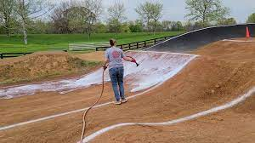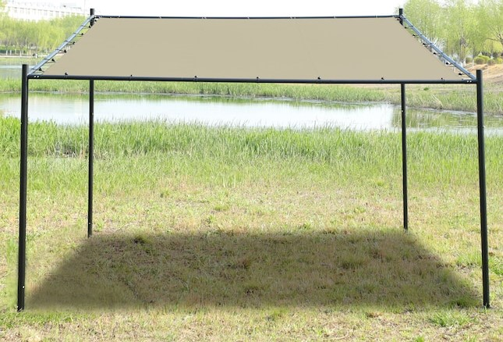
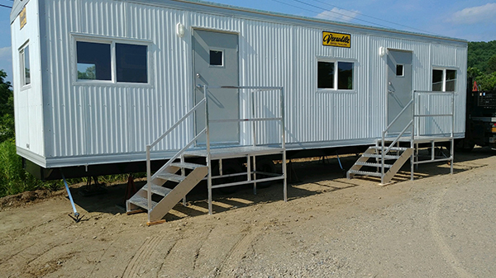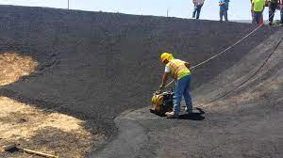

PARTNERSHIPS LEVELS OF SNAKE RIVER BMX

On behalf of I hereby commit to a financial/ in-kind partnership with Snake River BMX at the level of:
Gold Cup Package $1000 Initial Year
State Final Package $700 Initial Year
District Package $500 Initial Year
Strider Package $300
Start Hill Package $Other (see below)
- The estimated value for Chrome/Other donated to Snake River BMX is as follows:

Cash Donation $
Gift In-Kind $
Labor $
Materials $
Services / Other $
Total Donations $

Name: Title: Company/ Organization: Phone Number: E-Mail Address: Signature: Date:
Please complete the above form and bring it in or send it back along with your donation (if check – please make payable:) to Snake River BMX to the following address:
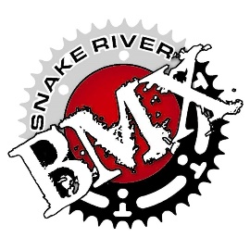
Snake River BMX
P.O. Box 2076
Idaho Falls, Idaho 83404

Would you like a Receipt of Charitable Donation?

The Snake River BMX Association is a recognized 501(c)(3) not-for-profit organization.

Federal ID number: TIN 82-0404999.

CONTACT US

WWW.SNAKERIVERBMX.COM

@SNAKERIVERBMX

@SNAKERIVERBMX

SNAKERIVERBMX1@YAHOO.COM
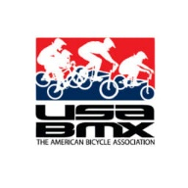

WWW.USABMX.COM

435-764-7086 TRACK OPERATOR- CASEY CHRISTENSEN

1860 E 65th South Idaho Falls, ID United States 83404

